<http://usefulldata.com/cheap-12v-temperature-controller-xh-w1209-with-display-and-probe-review/>

**PO Heating or Cooling ?**

Here we set the temeperature controller operation mode C- cooling , H-heating.

If you set Cooling (C) temperature controller will be activated relay when temperature falls to the setpoint.

If you set Heating (H) temperature controller will be activated relay when temperature raise to setpoint.

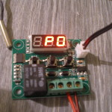

**P1 – Hysteresis or Return diference set**

This device model can value set by 0.1C and the lowest value is 0.1C.This is a very useful feature for precise operation of the temperature controller.For example, if you set the value of 1C and the desired temperature on the thermostat 20C relay will be deactivated at 21C (20C+1C). The relay is activated again when the temperature drops to 20C.

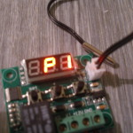

**P2 – Highest temperature limit**

You can set a maximum temperature limit, less than 110 degrees.

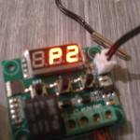

**P3 – Lowest temperature limit**

You can set minimum temperature limit more as 50 degrees.

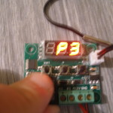

**P4- Temperature correct or calibration**

Very good feature that lets you set your thermostat by certified accurate thermometer.

If you do not have a certified thermometer leave the value at 0C. Calibration allows you to adjust the temperature in 0.1 increments.

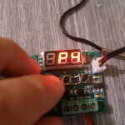

**P5-Delay starting time**

In this step, you set the start delay in minutes 1-10 min.If you set 1min relay is activated until one minute after reaching the set temperature.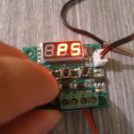

**P6-High temperature Alarm**

The menu P6 initially turns OFF to ON and press the SET,then set the temperature at which the alarm is activated. When is alarm activated display not showing temperature only – - -.

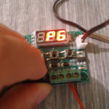

### **Other info**

The device has a low consumption of 25-35 mA at rest 50-75 mA when the relay is activated.

Be careful if the power supply voltage lower than 10V relay is not activated although the LED shining.

### **Price and buy**

Temperature controller can buy from Ebay or AliExpress, good price varies around about 3-6 usd shipping included.Keep in mind that at low cost 3-4 usd sell thermometers not temperature controllers but the XH-W1209 is very cheap

### **Complete technical parameters of temperature controller XH-W1209:**

* Control range: -50*-110 degrees Celsius
* Resolution: the -9.9-99.9 of 0.1 degrees Celsius, 1 degrees Celsius temperature section of the other
* Accuracy of temperature: 0.1 degrees
* The control accuracy: 0.1 degrees Celsius
* Return difference accuracy: 0.1 degrees Celsius
* The refresh frequency: 0.5s
* High temperature protection: 0-110 degrees Celsius
* Input voltage: DC 12V
* Measurement of the input: NTC (10K 0.5%) waterproof type sensor
* The output range: 1 10A relay
* Environmental requirements: -10-60 degrees Celsius, humidity: 20%-85%
* Size: 48*40mm
* Power consumption: static current: <=35MA operating current: <=65MA
* Display type: 0.28 inch three digital tube

### **Short manual again:**

Connect the power supply and the negative,

Can provide power supply controller for temperature measurement, displayed, press the SET key once, display temperature scintillation,Press +- to set the desired temperature, the setting is finished,

press SET as confirmed return,This controller according to the set to automatically perform the relay on-off. The temperature controller output for the 10A relay, to meet a variety of high power load, please ensure that the wiring is correct.

Indicator lights, digital tubes state description:

Indicator: put out the said relay disconnected, ofen light said the relay is closed,display HH for exceeding the measurement range,the thermostat will force disconnect relay;display – for high temperature protection.